**PRODUCT SALES ANALYSIS**

**PROJECT DEFINITION**:

Sales analysis is reviewing your sales data to identify trends and patterns. Sales data can help you make better decisions about your product, pricing, promotions, inventory, customer needs other aspects of your business. Sales analysis can be as simple as reviewing your sales figures regularly.

**OBJECTIVES FOR PROJECT**:

Sales objectives for selling products could include: Increasing the size of average deals. Increasing annual up-sells. Increasing quarterly cross-sells.

**DATA COLLECTION**:

**SOURCE:**

Most retail businesses use POS systems to record sales transactions .These systems automatically capture data on items sold , prices ,and transaction times.

Gather historical sales data, customer information, and any relevant variables that might influence sales, such as marketing spend, seasonality, or economic indicators.

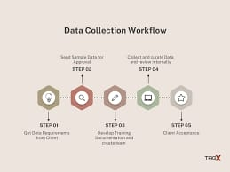

**Sample Data Base:**

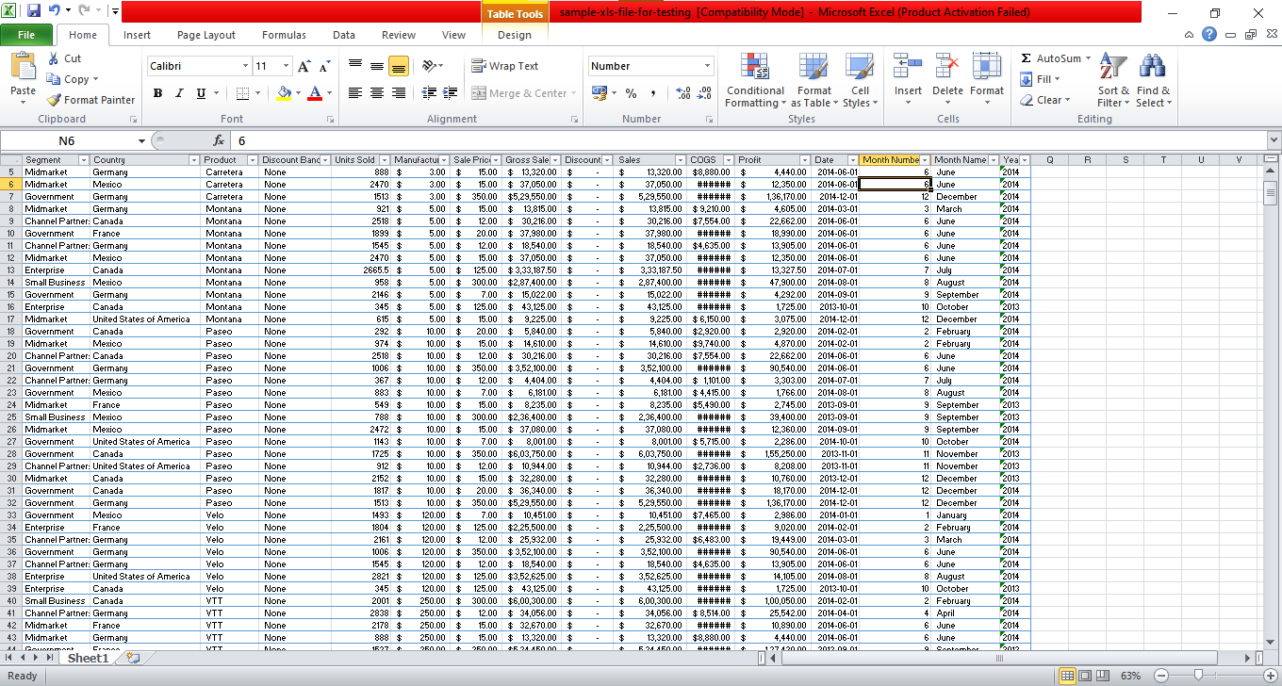

To conduct a more comprehensive product sales analysis in Python, we’ll cover various aspects such as data preprocessing, exploratory data analysis (EDA), key metrics calculation, and visualization. We’ll use sample sales data for demonstration purposes.

**ACTIONABLE INSIGHTS:**

Deriving insights from data analytics is crucial for guiding inventory management and market strategy in various ways:

• **Demand Forecasting:**

Analyzing historical sales data and market trends can help you forecast demand more accurately. This allows for better inventory planning, ensuring you have enough stock to meet customer demands without overstocking and tying up capital.

**• Inventory Optimization**:

Data analytics can identify slow-moving or obsolete inventory items. By identifying these items, you can make informed decisions on clearance sales, discontinuation, or adjustments to reorder quantities.

**• Seasonal Trends**:

Historical data can reveal seasonal fluctuations in demand. Armed with this insight, you can adjust your inventory levels and marketing strategies accordingly to capitalize on peak seasons.

**• Supplier Performance**:

Analyzing data on supplier lead times, delivery reliability, and quality can help you make data-driven decisions when selecting suppliers and negotiating contracts. This ensures a smooth supply chain.

• **Customer Segmentation:**

Segmenting your customer base based on purchase history, demographics, or behavior can guide targeted marketing efforts. It helps in tailoring product offerings and promotions to specific customer groups

**• Market Expansion**:

Data analytics can identify untapped markets or regions with potential growth opportunities. You can allocate inventory and marketing resources strategically to expand your market reach.

**• Price Optimization**:

Analyzing pricing data, competitor pricing, and customer behavior can inform pricing strategies. You can adjust prices dynamically based on demand and competition.

**• Inventory Turnover**:

Monitoring inventory turnover ratios can help you assess the efficiency of your inventory management. High turnover indicates efficient use of capital, while low turnover might suggest excess inventory.

**• Risk Management:**

Predictive analytics can help identify potential supply chain disruptions or inventory shortages. This allows you to proactively mitigate risks and ensure business continuity.

**• A/B Testing**:

Conduct controlled experiments to test marketing strategies or inventory management changes. Analyze the results to determine which strategies yield the best outcomes.

**• Customer Feedback Analysis**:

Analyze customer reviews and feedback to identify product improvement opportunities and address customer pain points, enhancing product offerings.

**• Competitive Analysis**:

Evaluate your competitors’ inventory management and market strategies through data analysis. This can reveal gaps in the market or areas where you can differentiate your offerings.

To achieve these benefits, organizations often employ data analytics tools and techniques, including data mining, machine learning, and business intelligence platforms. Continuous monitoring and adjustment based on data-driven insights are key to effective inventory management and market strategy in today’s dynamic business environment

**Data visualisation:**

1.*Analyze the Chart:* Observe the products with the tallest bars in the chart. These represent the products with the highest sales.

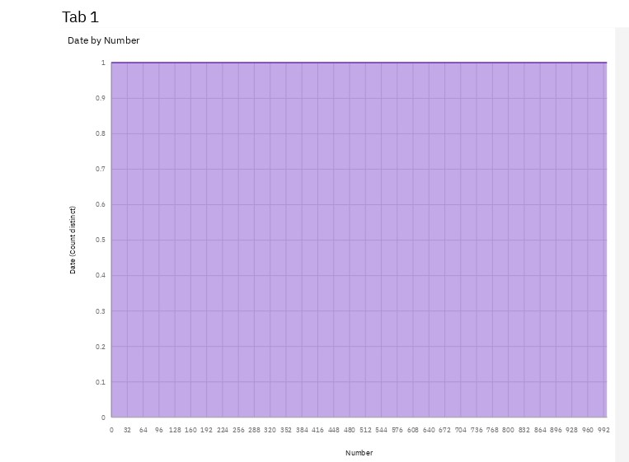

By following these steps and creating a visual representation of your sales data, you can quickly identify the products with the highest sales.

2.*Create Time Series Visualizations:* Use line charts or bar graphs to visualize the sales data over time. The x-axis should represent the time intervals, and the y-axis should represent the total sales amount for each period.

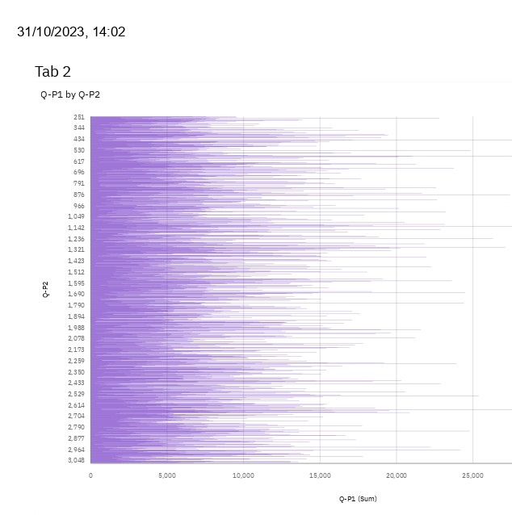

3. *Sentiment Analysis:* Analyze customer reviews and feedback using natural language processing (NLP) techniques to gauge customer sentiment towards products. Positive or negative sentiment can influence sales and product improvements.

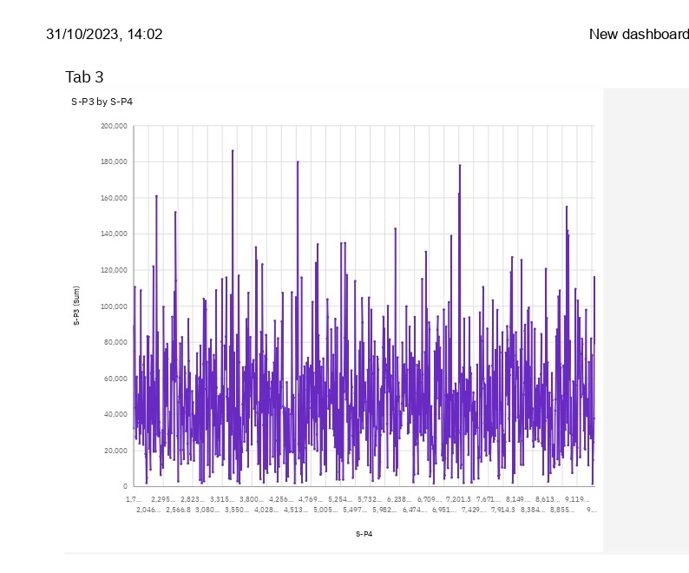

4. *Geospatial Analysis:* If sales data includes geographical information, use geospatial analysis to visualize sales patterns on maps. This can reveal regional preferences and assist in targeted marketing campaigns.

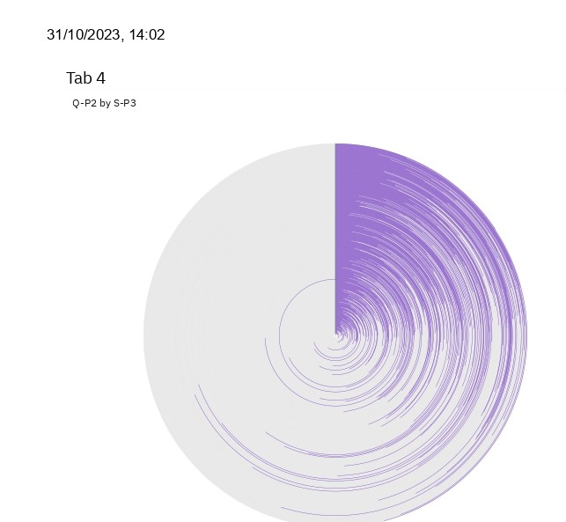

5. *A/B Testing:* Conduct controlled experiments (A/B tests) to compare different marketing strategies or product variations. This data-driven approach helps in understanding what resonates best with customers and drives higher sales.

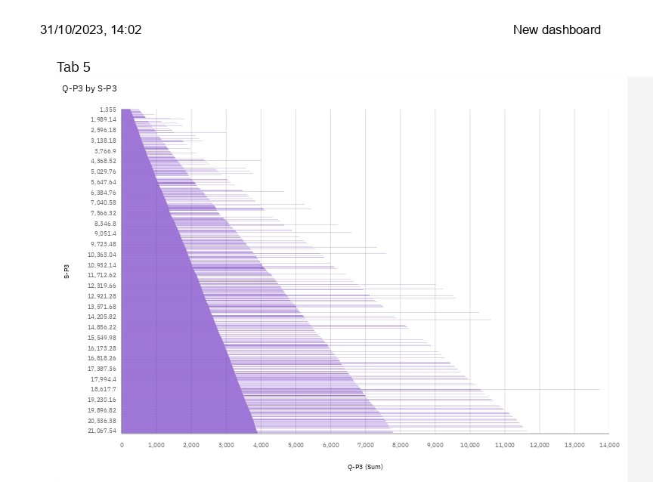



6. *Cohort Analysis:* Group customers based on their signup or first purchase dates. Analyze how different cohorts behave over time to understand customer loyalty, purchasing patterns, and revenue trends.



7.*Social Media and Web Analytics Integration:* Integrate social media and website analytics data with sales data to understand the impact of online presence on product sales. Track referral sources, user engagement, and conversion rates.

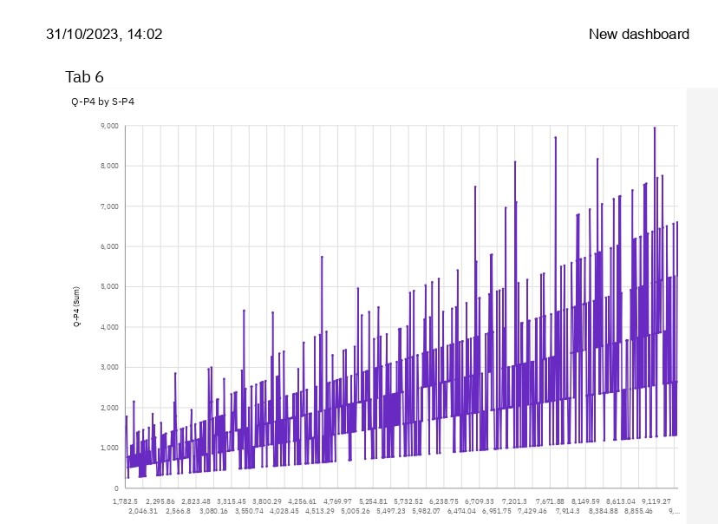

**Identify Products with Highest Sales:**

1. *Examine Sales Data:* Look at your sales dataset, focusing on the total sales figures for each product.

*#Import libraries*

import numpy as np

import pandas as pd

import seaborn as sns

import matplotlib.pyplot as plt

import warnings

warnings.simplefilter(action = 'ignore', category = **Warning**)

import os

for dirname, _, filenames **in** os.walk('/kaggle/input'):

for filename **in** filenames:

print(os.path.join(dirname, filename))

/kaggle/input/sales-product-data/Sales_August_2019.csv

/kaggle/input/sales-product-data/Sales_May_2019.csv

/kaggle/input/sales-product-data/Sales_February_2019.csv

/kaggle/input/sales-product-data/Sales_November_2019.csv

/kaggle/input/sales-product-data/Sales_January_2019.csv

/kaggle/input/sales-product-data/Sales_March_2019.csv

/kaggle/input/sales-product-data/Sales_September_2019.csv

/kaggle/input/sales-product-data/Sales_April_2019.csv

/kaggle/input/sales-product-data/Sales_July_2019.csv

/kaggle/input/sales-product-data/Sales_October_2019.csv

/kaggle/input/sales-product-data/Sales_June_2019.csv

/kaggle/input/sales-product-data/Sales_December_2019.csv

1. *Sort Products by Sales:* Arrange the products in descending order based on their sales figures. This can be done using spreadsheet software, data analysis tools, or programming languages like Python or R.



3. *Visualize the Data:* Create a bar chart or a similar visualization where products are represented on the horizontal axis and their corresponding sales figures on the vertical axis. This visual representation makes it easy to identify products with the highest bars, indicating the highest sales.

files = [file for file **in** os.listdir('../input/sales-product-data')]

for file **in** files:

print(file)

Sales_August_2019.csv

Sales_May_2019.csv

Sales_February_2019.csv

Sales_November_2019.csv

Sales_January_2019.csv

Sales_March_2019.csv

Sales_September_2019.csv

Sales_April_2019.csv

Sales_July_2019.csv

Sales_October_2019.csv

Sales_June_2019.csv

Sales_December_2019.csv

**Data Cleansing:**

*#Merge the 12 months of sales data into a single file*

*#Create empty data frame for all data*

all_data = pd.DataFrame()

*#Make a loop for Concatenate the data*

for file **in** files:

data = pd.read_csv("../input/sales-product-data/" + file)

all_data = pd.concat([all_data, data])

all_data.head()

**Determine Peak Sales Periods:**

1. *Collect Time-Stamped Sales Data:* Ensure your sales data includes timestamps (dates and times) for each transaction.

import numpy as np

import pandas as pd

import seaborn as sns

import matplotlib.pyplot as plt

import warnings

warnings.simplefilter(action = 'ignore', category = **Warning**)

import os

for dirname, _, filenames **in** os.walk('/kaggle/input'):

for filename **in** filenames:

print(os.path.join(dirname, filename))

/kaggle/input/sales-product-data/Sales_August_2019.csv

/kaggle/input/sales-product-data/Sales_May_2019.csv

/kaggle/input/sales-product-data/Sales_February_2019.csv

/kaggle/input/sales-product-data/Sales_November_2019.csv

/kaggle/input/sales-product-data/Sales_January_2019.csv

/kaggle/input/sales-product-data/Sales_March_2019.csv

/kaggle/input/sales-product-data/Sales_September_2019.csv

/kaggle/input/sales-product-data/Sales_April_2019.csv

/kaggle/input/sales-product-data/Sales_July_2019.csv

/kaggle/input/sales-product-data/Sales_October_2019.csv

/kaggle/input/sales-product-data/Sales_June_2019.csv

/kaggle/input/sales-product-data/Sales_December_2019.csv

**Conclusion:**

The analysis of product sales provides valuable insights into the performance and dynamics of a business’s revenue-generating activities. Drawing conclusions from such an analysis is crucial for making informed decisions and improving overall business strategy. Here are some key conclusions that can be derived from a product sales analysis:

**Identifying Top-Performing Products:** The analysis can highlight the products that consistently outperform others in terms of sales. This information is essential for focusing on high-impact items and optimizing inventory management.

**Seasonal Trends:** Product sales analysis can reveal seasonal fluctuations in demand. Understanding these patterns is vital for effective inventory planning, marketing campaigns, and cash flow management.

**Customer Preferences:** By examining the sales data, businesses can gain insights into customer preferences. This information can inform product development and marketing strategies, helping to better meet customer needs.

**Pricing Strategies:** Sales data can shed light on how pricing affects sales volumes. It can help in adjusting pricing strategies to maximize both revenue and profit margins.

**Market Penetration:** The analysis can also reveal how well a product is penetrating its target market. This information can guide expansion efforts and market-specific strategies.

**Competitive Analysis:** By comparing sales performance with competitors, businesses can assess their market position and make adjustments to stay competitive.

**Inventory Management:** Understanding which products are slow-moving or fast-moving helps in optimizing inventory levels and reducing carrying costs.

**Marketing Effectiveness:** The analysis can provide insights into the effectiveness of marketing campaigns. It helps to understand which strategies and channels are driving sales and which ones need adjustment.

**Customer Segmentation:** By analyzing sales data, businesses can identify different customer segments and tailor marketing efforts and products to specific customer groups.

**Forecasting and Planning:** Sales data analysis is fundamental for creating accurate sales forecasts and business plans. This enables proactive decision-making and resource allocation.